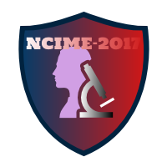

**Benefits of Conference**

* All selected papers will be published in NCIME-2017 conference proceedings.
* All selected papers will be published in Reputed Indexed Journals. (Springer, Web of Science, Thomson Reuters, Google Scholar).
* Corresponding Author and Co-authors will get Conference Paper publication certificates.
* Author will get soft copy (CD/DVD) of conference proceedings.
* Author will get soft/hard copy of published journal papers.